**Installing Python on Windows**

**A. INSTALLING VIRTUAL STUDIO CODE:**

A.1.1: Go to the Visual Studio Website at [VS Code](https://code.visualstudio.com/), and download file for Windows

A.1.2. Go to downloads and open the Virtual Studio Code installer. Accept the agreement, choose the installation folder, and pick the default settings:

A.1.3 Select the color theme. I personally use the “Light” version but this is largely a matter of taste. There is no need for any further customization at this stage.

For now, leave the rest of the options blank in the next two screens. You can come back to these later in the “Getting Started” tab of VS Code. When you’re finished selecting the options click on “Mark Done”

A.2.1 Go to <https://marketplace.visualstudio.com/items?itemName=ms-python.python> and download the Python extension for VS-Code. Click on “Install”. When you see the popup, click “Continue”. When it asks you to open Visual Studio Code click “Allow”. The link should lead you back to Visual Studio, in the Extensions tab. Click on “Install”.

A screen will appear for you to create a Jupyter Notebook. For now, click “Mark Done”.

NOTE: At this stage we’ve only downloaded the graphical interface but not the Python Interpreter software itself. We are not ready to run Python code just yet!

**B: Installing Python**

B.1 Download the latest version of Python from <https://www.python.org/downloads/>. When you get a pop-up window, click “Allow”. Go to downloads and open the Python installer.

Make sure to select the option “add python.exe to PATH”. This makes it easier for other applications to work with Python.

Click on all “Continue” options with the defaults and select the installation location.

**C. Connecting Python with Visual Studio Code**

C.1 Open VS-Code, go to the lower left corner and click the Settings button (the gear symbol). Then click “Command Palette”.

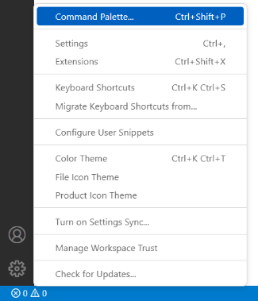

C.2 You will get a search bar, where you should type “Python”. You will get several options. Click on “Python: Select Interpreter”.

C.3 Select your preferred Python installation. If this is your first installation you will only get one option.

**D. Install key packages:**

Open the terminal (in Windows this is called the Command Prompt)[1].

Run the following command (updates your package manager)

python -m pip install --upgrade pip

Run the following command (install the jupyter notebook library for Python)

pip3 install jupyter

**Opening your first notebook in VS-Code**

Open VS-Code and select “New File”. You will get a pop-up window. Select “Jupyter Notebook”. This will open a new tab with a “Jupyter-Notebook” File. You will see a file with an empty gray box. Type in the following command in the box:

print(“Hello World”)

Then click the “Run all” button in the top panel. You should now see the output below the box, with your desired text. Try to play around with including your own text. NOTE: print() is our first example of a function that takes a text as an input and output the desired message on the console. We have to denote text between quotations. Welcome to Python!

1. In Windows you can typically open the command prompt clicking on the Windows key then searching “Command Prompt”. This will open a black screen with white font. Try to run the command prompt from an account with administrator privileges.